Sales Data Transformation and Data Modeling
Objective:
This project focuses on transforming raw sales data into a structured and analysis-ready format using Power Query and building an efficient data model in Power BI. Data cleaning processes include handling missing values, removing duplicates, correcting data types, creating calculated columns, and optimizing data quality. A star schema data model is designed by establishing relationships between fact and dimension tables to improve performance and enable accurate reporting.

Dataset Description:
The dataset contains the following columns.
Column description:
Column Name | Description
Order Id | Order ID of the Product
Order Date | Order Date of the Product
Customer Name | Customer Name of the Product
State | State Name of the Customer
City | City Name of the Customer
Amount | Price of the Product
Profit | Profit of the Product
Quantity | Quantity of the Product
Category | Category of the Product
Sub-Category | Sub-Category of the Product
Month of Order Date | Order Date of the Sales
Target | Target for the Sales
Location | Newly Added City with State column
Profit Margin | Newly Calculated the Profit Margin
Profit Status | Newly Calculated the Profit status
Formulas Used:
- To find the Profit Margin
Formula: Profit / Amount
- To find the Profit Status

Formula:
■ Profit < 0 → Loss
■ Profit = 0 → Break-Even
■ Profit > 0 → Profit

Conclusion:
The project demonstrates best practices in data preparation, transformation, and data modeling that support effective business intelligence and decision-making.
Newly merged table as Orders Data:

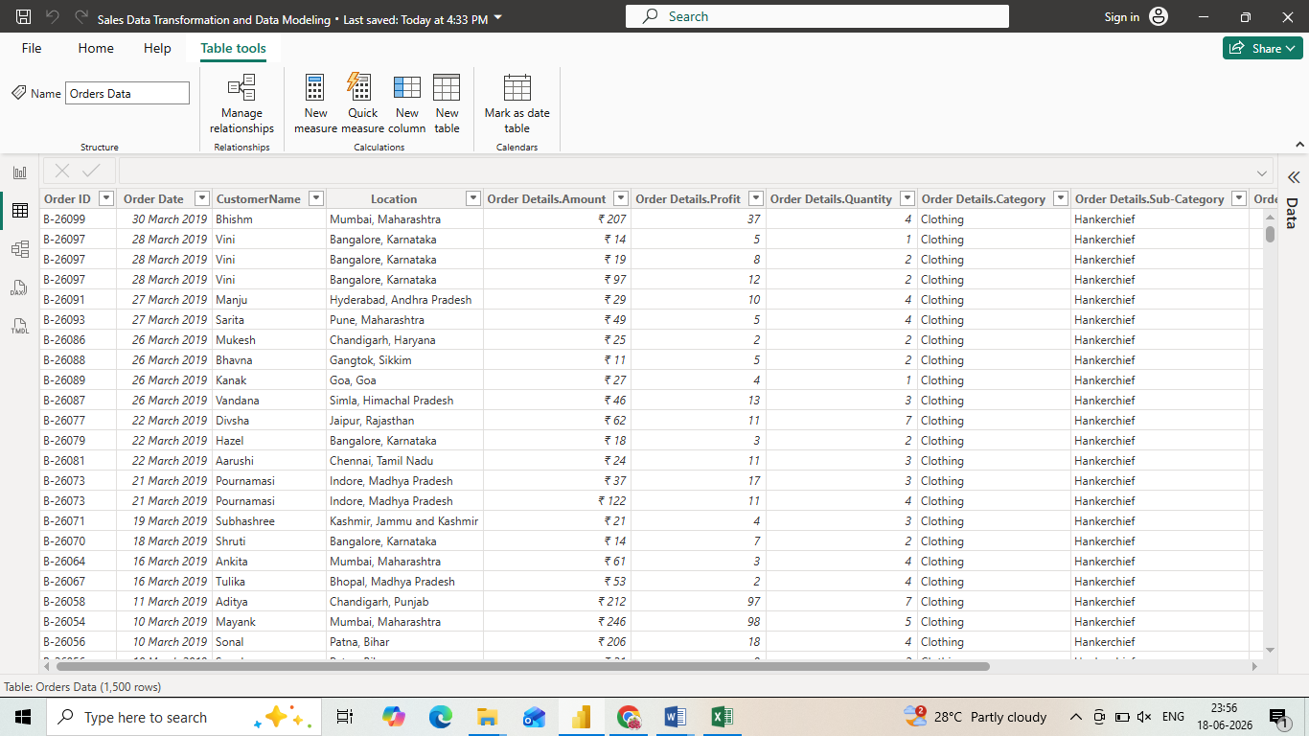
Data Modelling:

